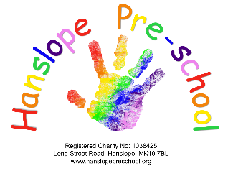

Student Placement Policy

Date reviewed: 07.04.2025

**Policy statement**

We recognise that qualifications and training make an important contribution to the quality of the care and education we provide. As part of our commitment to quality, we offer placements to students undertaking Early Years qualifications and training. We also offer placements for school pupils for work experience.

We aim to provide students on placement with us with experiences that contribute to the successful completion of their studies and that provide examples of quality practice in early years care and education.

**Procedures**

* We require students on qualification courses to meet the 'Suitable Person' requirements of the Early Years Foundation Stage and have a satisfactory enhanced DBS check with barred list check(s).
* We require students in our setting to have sufficient understanding and use of English to contribute to the well–being of children in our care.
* We require schools, colleges, or universities to place students under the age of 17 years in the Pre-school to vouch for their good character.
* We always supervise students under the age of 17 years and do not allow them to have unsupervised access to children.
* Students undertaking qualifications courses, who are placed in our Pre-school on a short-term basis, are not counted in our staffing ratios.
* Students and apprentices, over the age of 17, who are undertaking a level 3 qualification, may be counted in ratios if our Practice Manager deems them to be suitably qualified and experienced.
* Trainee staff and students over the age of 17 and employed by the Pre-school may be included in the ratios if they are deemed competent and responsible.
* We take out employers’ liability insurance and public liability insurance, which covers trainees, students, and voluntary helpers.
* We require students to keep to our confidentiality and Children’s Records policy. Any information gained by the students about the children, families, or other adults in the Pre-school must remain confidential.
* We cooperate with students’ tutors to help students fulfil the requirements of their course of study.
* We provide students, at the first session of their placement, with a short induction on how our Pre-school is managed, how our sessions are organised, and our policies and procedures.
* We communicate a positive message to students about the value of qualifications and training.
* We make the needs of the children paramount by not admitting students in numbers that hinder the essential work of the Pre-school.
* We ensure that trainees and students placed with us are engaged in bona fide early years’ training, which provides the necessary background understanding of children’s development and activities, unless the student is on a work experience placement from school.
* Students required to conduct child studies will obtain written permission from the parents of the child to be studied.

This policy was reviewed by Hanslope Pre-school on 7th April 2025

To be reviewed on the 1st of September 2025

Signed on behalf of Hanslope Pre-school

By Emma Courtney

Chairperson

Date: 25.06.2025